**Content**

1. Introduction into OS 2

1. Computer System Operation 2

2. Storage Structure 2

3. I/O Structure 2

1. Introduction into OS

Linux is a KERNEL over which distributions (also called Distros) or full OS are built. Ubuntu is one such distro based on the Linux Kernel. There are many other distros as well, like Linux Mint, Fedora, CentOS, etc.

One may casually refer to any Linux based OS as "Linux". But Linux itself is only the Kernel and the full Operating Systems based on this kernel are many.

The symbol used in the lecture for Linux (the penguin) is the official mascot of the Linux Kernel. (Fun Fact: Its name is "Tux")

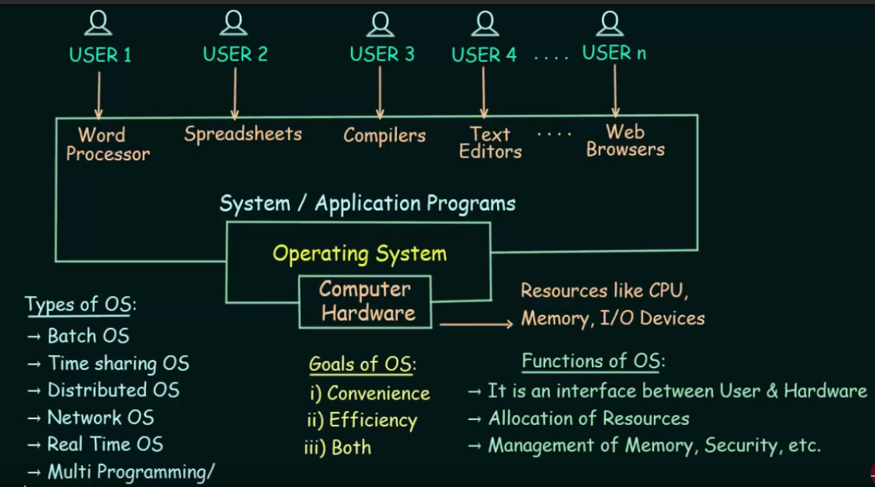

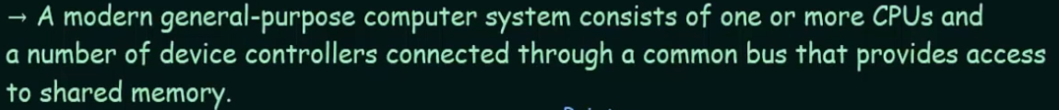

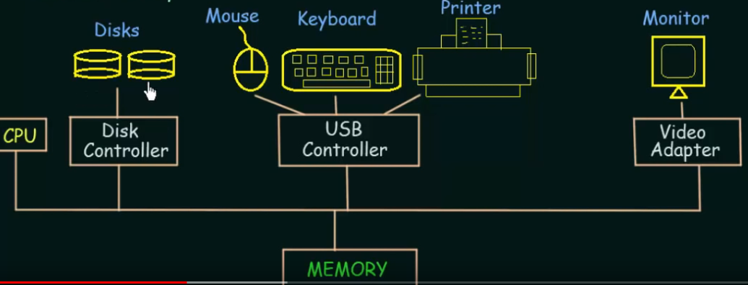

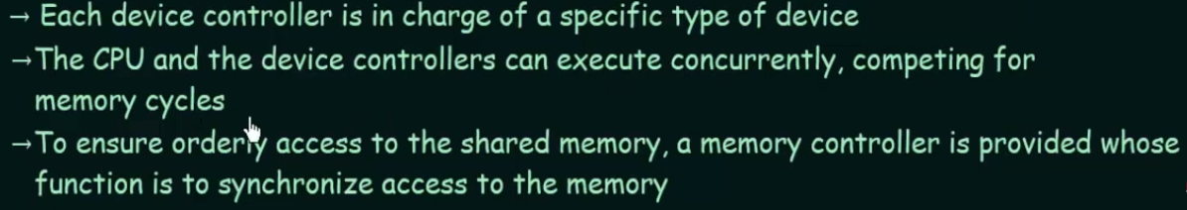

Whenever you execute something it needs to be loaded to the main memory (RAM ?!)

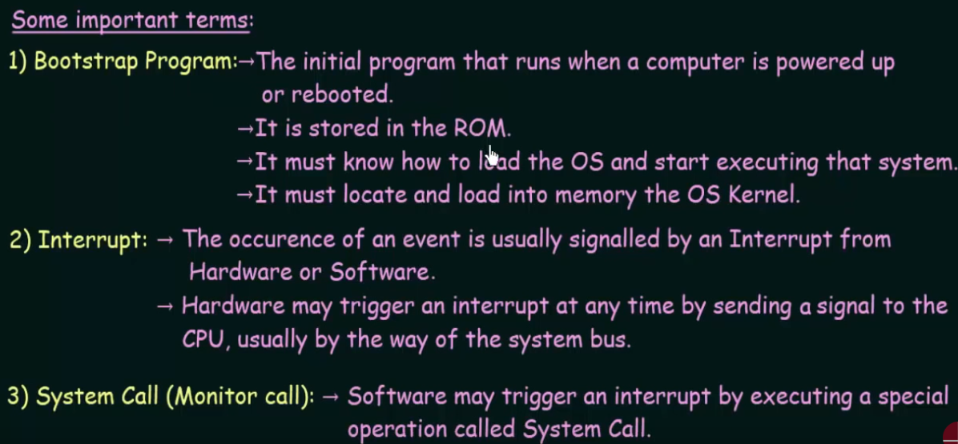

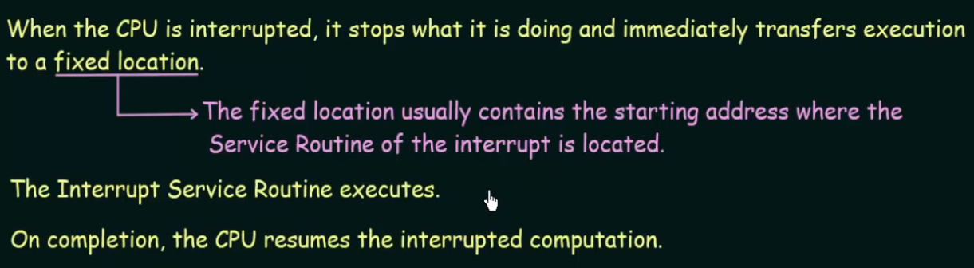

* 1. Storage Structure

Registers – smallest devices, store data in bits. Can be accessed very quickly.

Cache – little bigger little slower.

Main Memory – RAM. Things are stored in secondary memory, but they are loaded into main memory. They are volatile in nature.

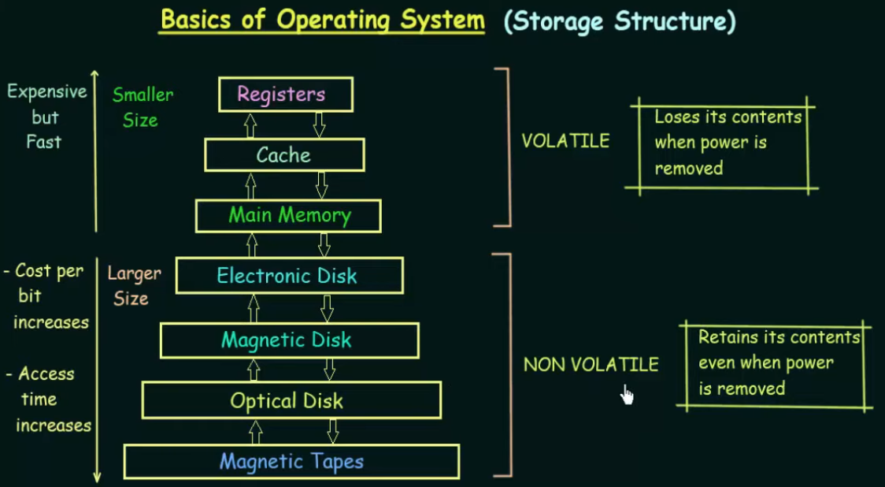

* 1. I/O Structure

